IMPACT 2022 Sponsorship Package
IMPACT 2022 Conference, which is organized by IEEE-EPS-Taipei, iMAPS-Taiwan, ITRI, and TPCA, is the largest gathering of PCB and packaging professionals in Taiwan. This year will be held on Oct. 26th -28th at Taipei Nangang Exhibition Center, in conjunction with TPCA Show 2022. For grasping the latest trend, the symposium highlights the theme “IMPACT on Empowered Edge Computing", which will explore the latest advances, challenges, and hot topics relevant to advanced research in packaging and PCB field. Meanwhile, IMPACT keeps collaborating with international organizations such as ICEP, JIEP from Japan and iNEMI from U.S.A and furthermore, cooperates with global consulting company, such as Yole Développement and Techsearch.
Being a sponsor of IMPACT 2022 will allow your company to get first hand access to the state-of-the-art research and demonstrate your novel products and innovations with decision makers. Other benefits including company promotion, recruitment opportunities and re-establishing your company’s image. We hope you’ll join us as a valued supporter.

Sincerely,

Chih-I Wu, Ph.D.
General Chair of IMPACT 2022
Vice President & General Director, ITRI

【Date】Oct. 26th(Wed)-28th(Fri),2022 【Venue】Taipei Nangang Exhibition Center
【Theme】IMPACT on Empowered Edge Computing
【Exhibition】TPCA Show, TAITRONICS, OPTO TAIWAN, AIoT Taiwan
【On-line Submission】www.impact.org.tw
【IMPACT 2021 Flashback】
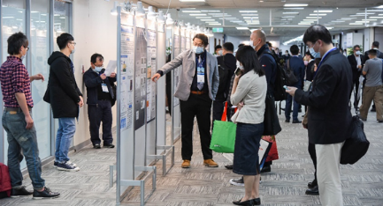 | 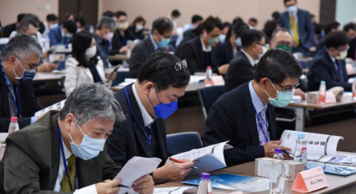 | 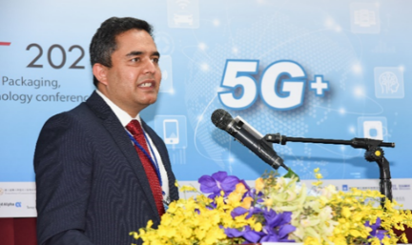
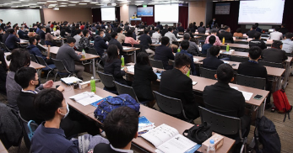 | 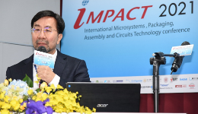 | 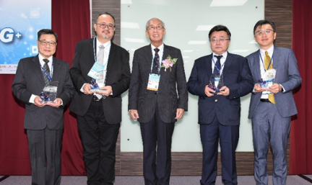
【Sponsorship Package】 ** Exclusively
Sponsorship | Industrial Forum / Special Forum |  | Golden | Silver | Bronze | Table  Show  ** | Flash Drive  ** | Badge  ** | Gift proposed by Company
$ (K NTD) | 200 | 160 | 100 | 80 | 50 | 80 | 150 | 50 | 160
Free Registration | 20+  Invited | 10+  Invited | 8 | 6 | 3 | 3 | 4 | 3 | 4
Logo on all conference materials | V |  | V | V | V | V | V | V | V
Logo listed on Industrial or special forum | V |  | X | X | X | X | X | X | X
Advertising printed in Proceedings | 1 Page |  | 1 Page | ½  Page | X | X | X | X | X
Digital posters | V |  | V | V | V | X | X | X | X
Corporate Video | V |  | V | V | V | V | X | X | X
Provide an IBM table | X |  | X | X | X | V | X | X | X
Exclusive EDM | V |  | X | X | X | X | X | X | X
LOGO listed on pen | X |  | V | X | X | X | X | X | X
LOGO listed on gift | X |  | X | X | X | X | V | V | V
Extra  registrations | $30,000: 5 registrations (original price: 105,000 )  $50,000:10 registrations (original price: 210,000)

IMPACT 2022 Agenda (TBD)
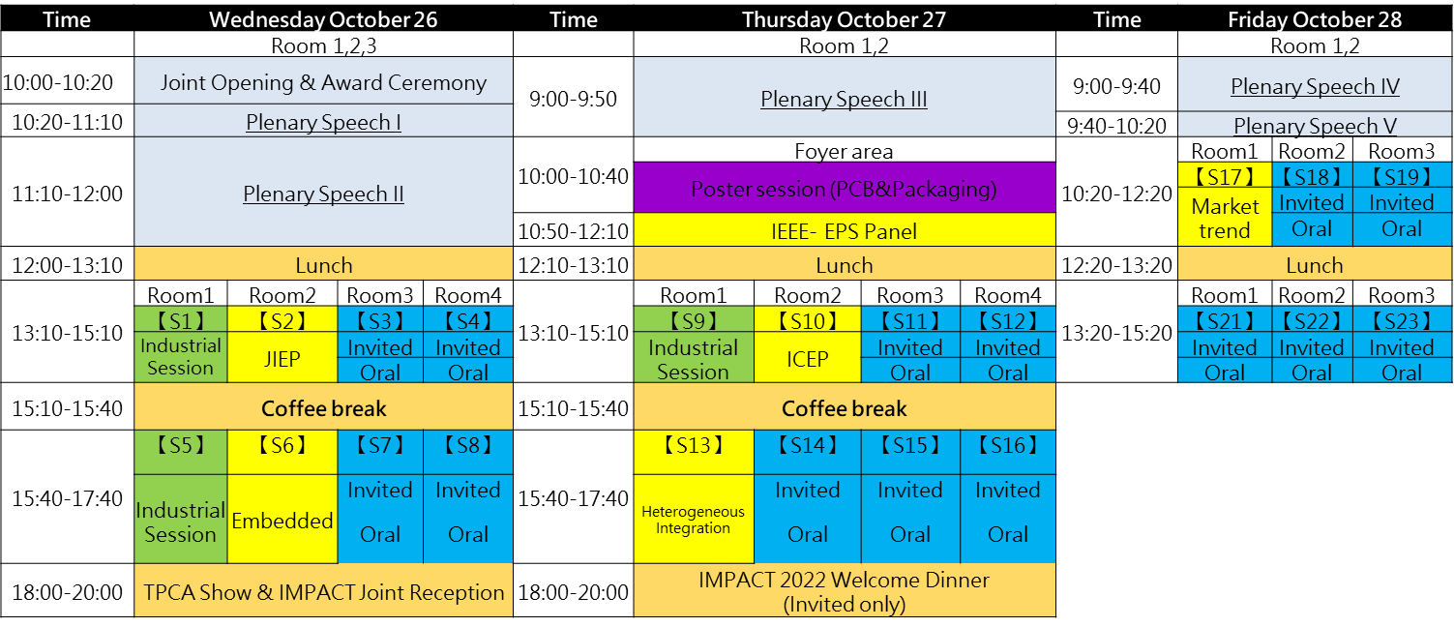

Sponsorship Package
Company Profile
Company Name
Contact Person |  |  | Job Title
Phone/ext. |  |  | Fax
E-Mail |  |  | Business No
Address |  |  | Webpage
Company Logo | Please email your Logo to service@impact.org.tw
Honored Advisor as a representative in IMPACT 2021 |  | Name
 |  | Job Title
 |  | E-Mail
SPONSORSHIP：Please your preferred sponsorship
Sponsorship | Sponsor Fee  (K NTD) | Free Registrants
Industrial Forum | - $200 | 20+Invited Speakers
 | - $ 160 | 10+Invited speakers
Special Forum；Topic: | - $200 | 20+Invited Speakers
 | - $ 160 | 10+ Invited Speakers
Gold | - $ 100 | 8
Silver | - $ 80 | 6
Bronze | - $ 50 | 3
Table Show (Exclusively) | - $80 | 3
Flash Drive (Exclusively) | - $ 150 | 4
Badge (Exclusively) | - $50 | 3
Gift proposed by Company | - $ 160 | 4
Extra Registrations | - $ 30 | 5
 | - $ 50 | 10

Payment details

Account Name | Taiwan Printed Circuit Association | Secretariat Address | No 147, Sec 2, Gaotie N Rd, Dayuan, Taoyuan 33743, Taiwan
Swift Code | LBOTTWTP013 | Account Number  (A/C No) | 131-001-00069-9
Bank No/ABA No | 122042564
Bank Name | Land Bank of Taiwan (Taoyuan Branch) | Bank Address | No. 75, ChungCheng Rd., Taoyuan 330, Taiwan
IMPACT Reference

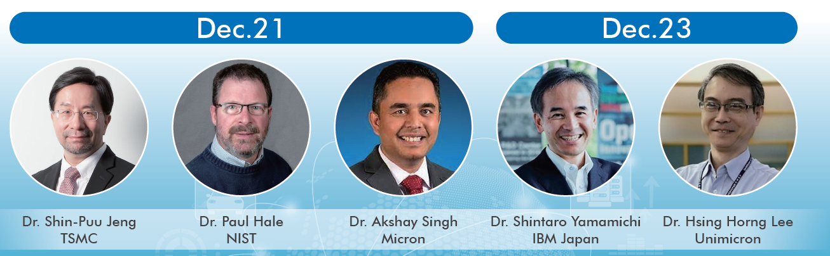
IMPACT 2021 Plenary Speakers
Paper statistics
Papers | 2021 | 2020 | 2019 | 2018
Poster | 37  (P-25,B-12) | 32  (P-21,B-11) | 33  (P-23, B-10) | 43  (P-32,B-11)
Oral | 70 | 71 | 76 | 80
Invited | 46 | 35 | 63 | 54
Industrial Forum | 19 | 19 | 23 | 9
Plenary | 5 | 5 | 6 | 6
Total | 177 | 162 | 201 | 192

Conference Attendee statistics

